Ex No: 3 CREATION AND UPDATION OF VIEWS

Date: 04.02.2020

**Aim**

To execute commands in creation and updating of views

**VIEW:**

In SQL, a view is a virtual table based on the result-set of an SQL statement. A view contains rows and columns, just like a real table. The fields in a view are fields from one or more real tables in the database. You can add SQL functions, WHERE, and JOIN statements to a view and present the data as if the data were coming from one single table. A view always shows up-to-date data

**QUERIES:**

1.**Create view**

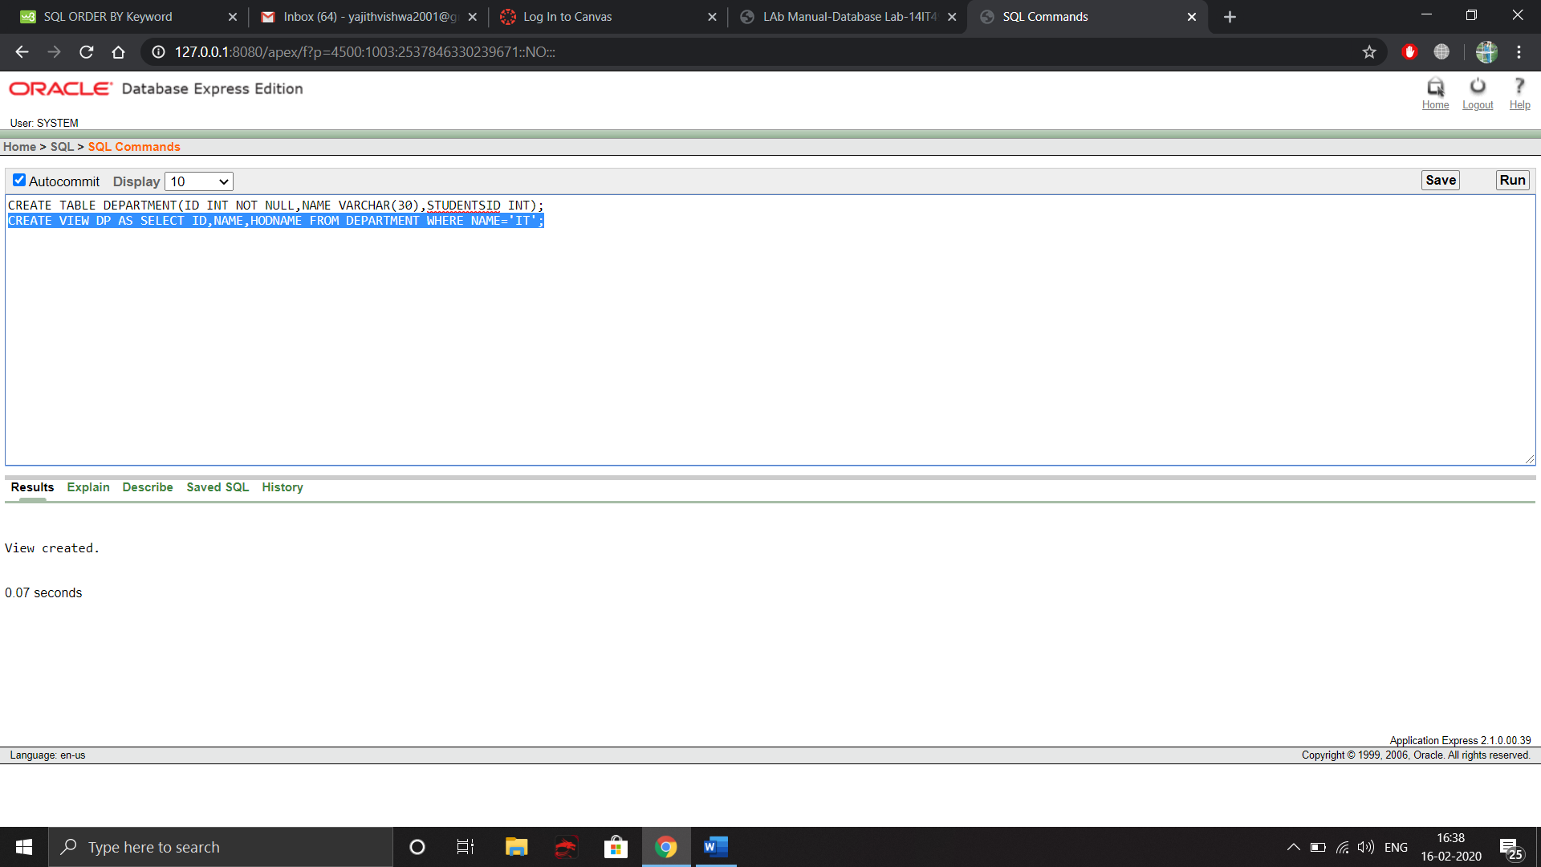

**2. Insert in view**

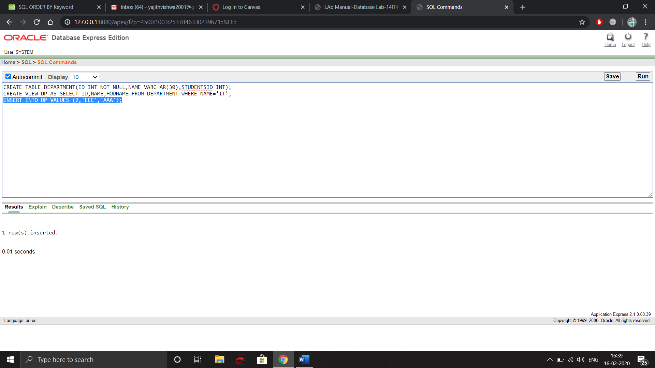

**3. DELETE IN VIEW**

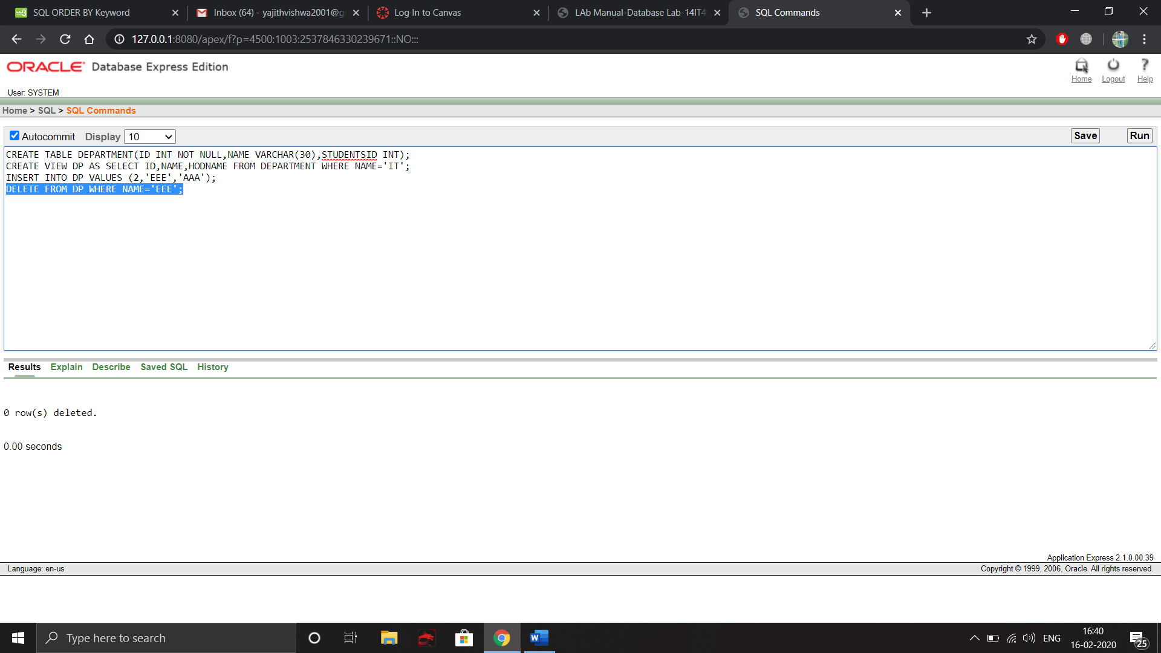

**4.Update View**

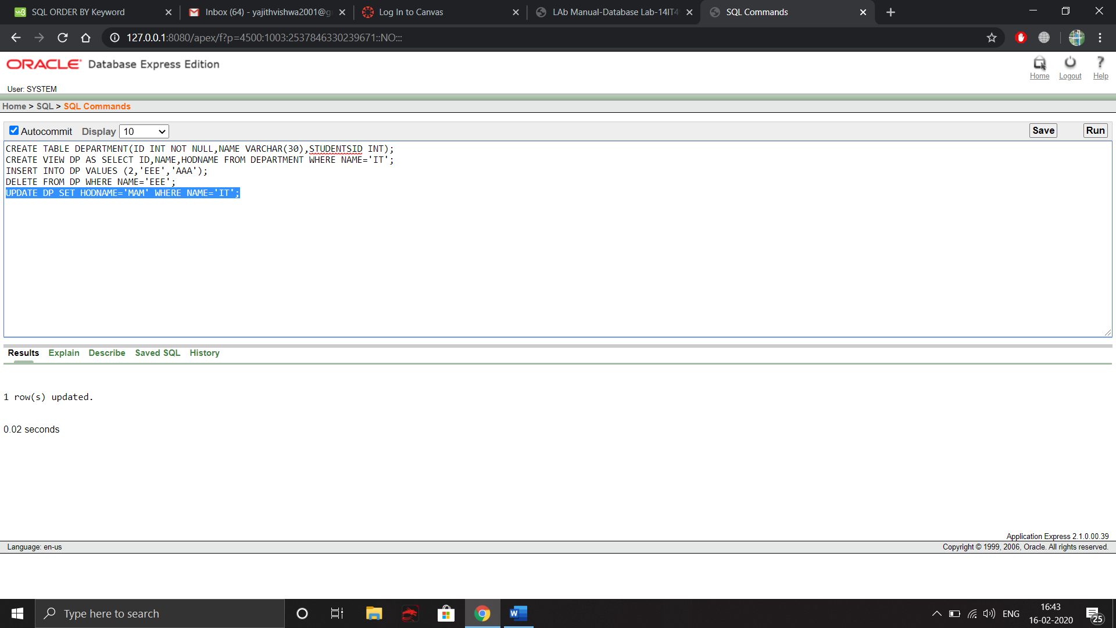

**5.Drop View**

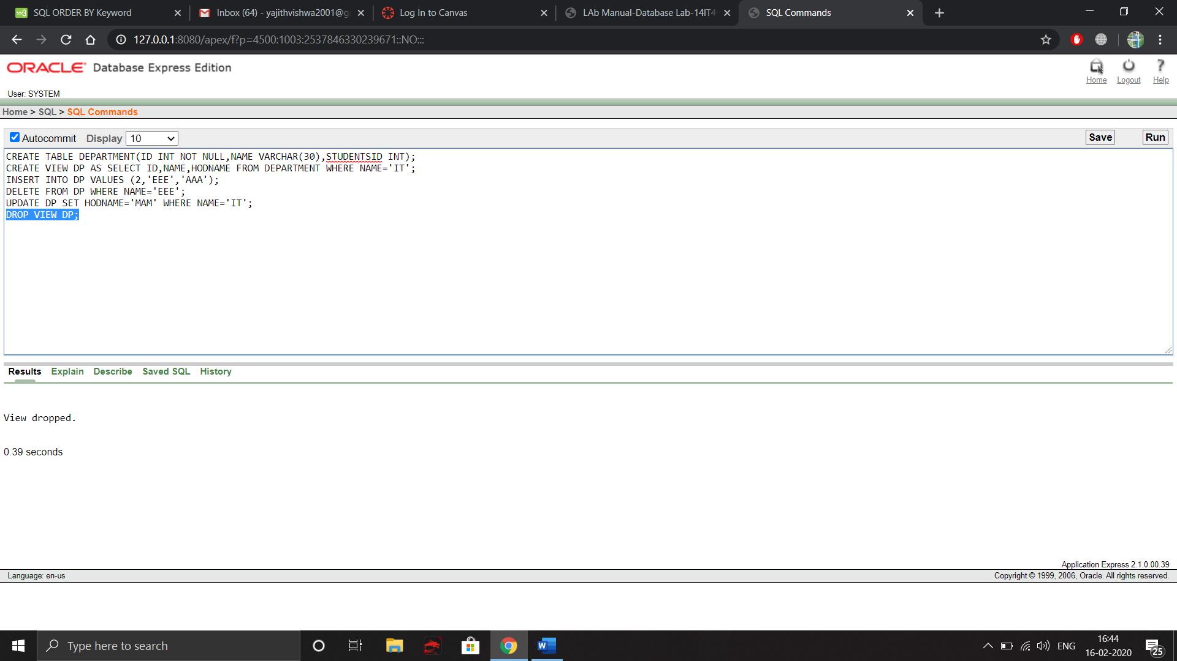

**6.Order By Command**

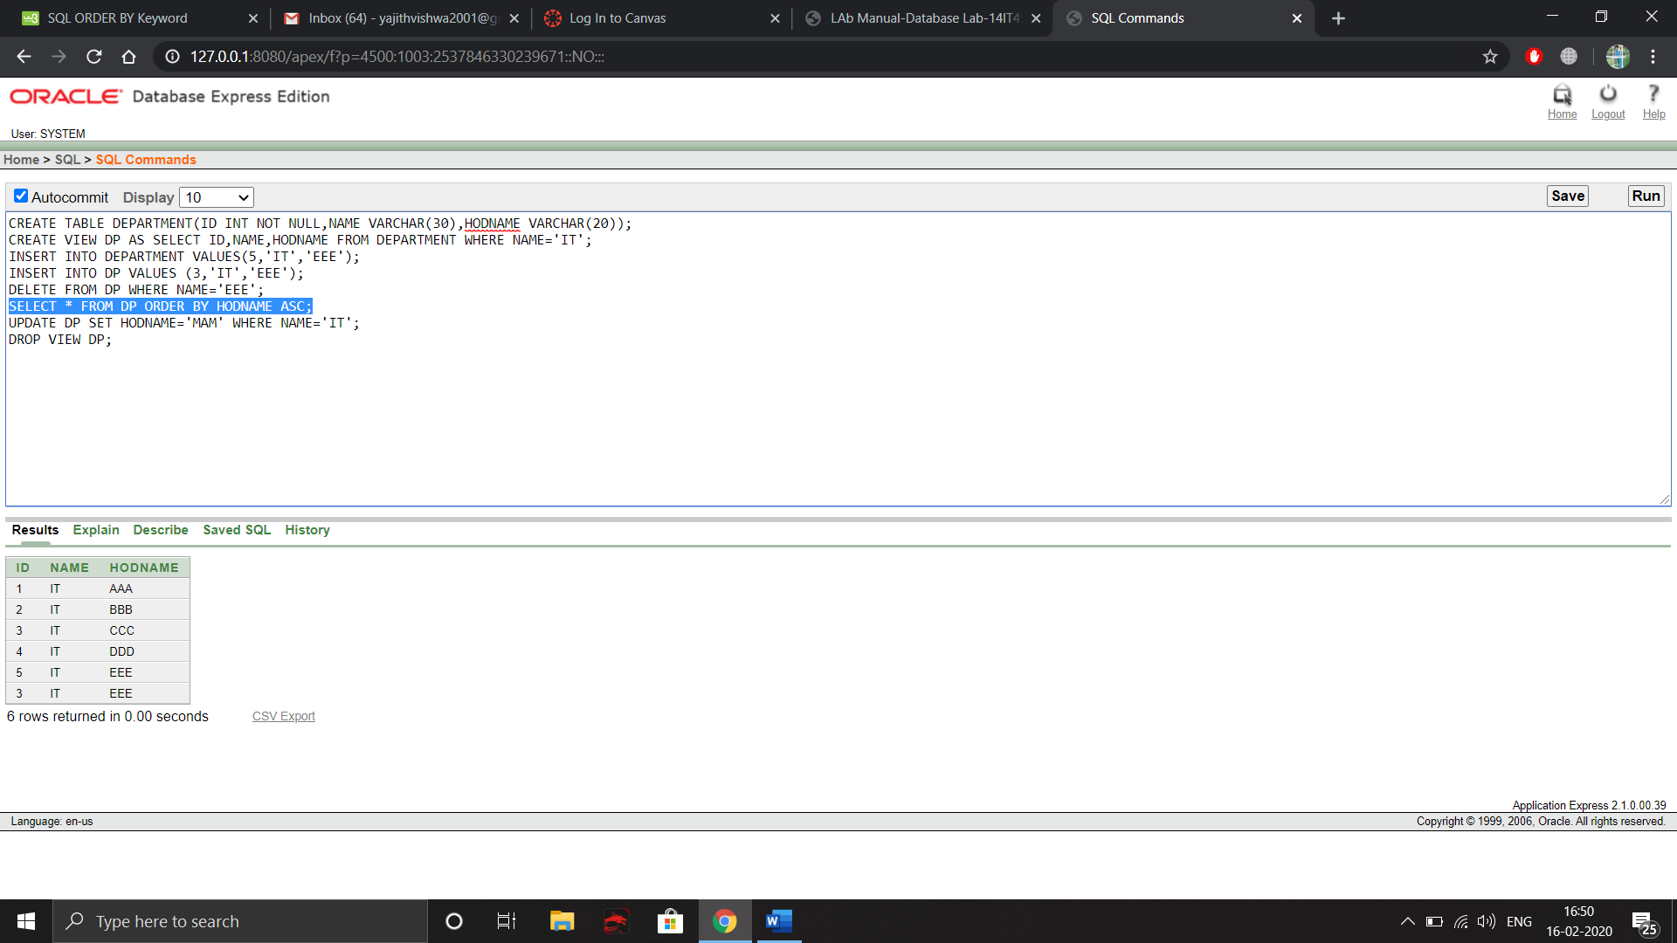

**7.With Read Only Constraint**

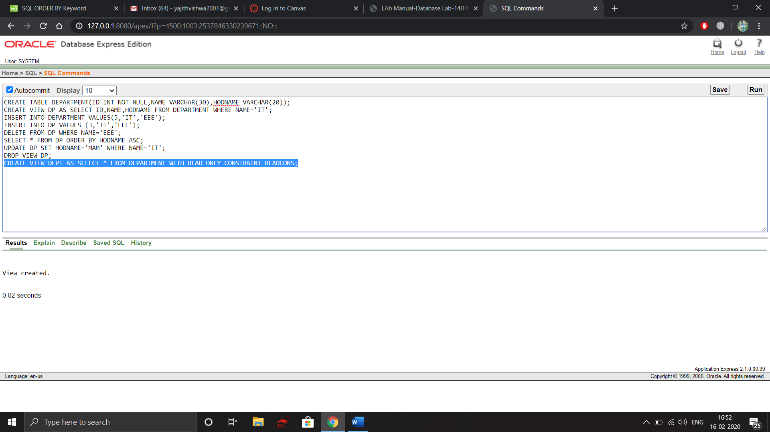

**8.** **Execute DML commands in view table and check whether it is reflected in main table.**

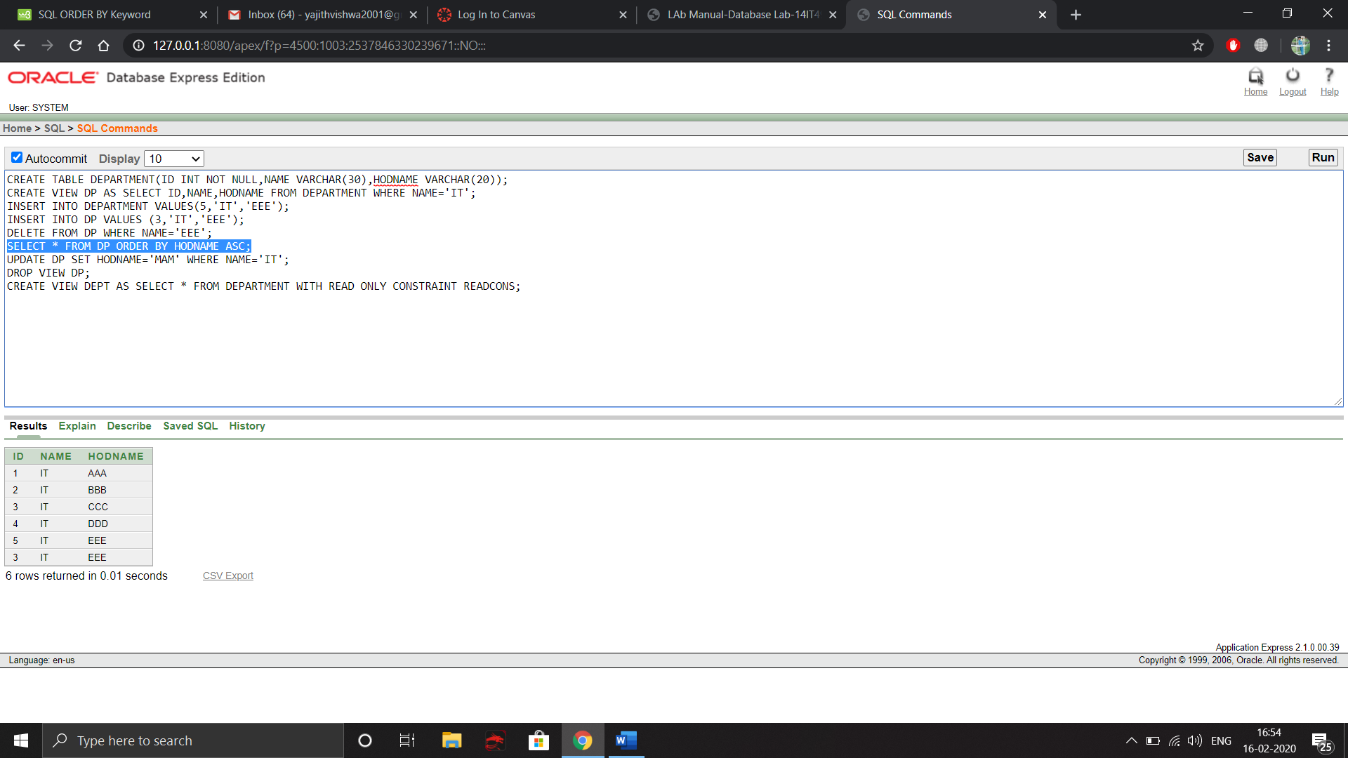

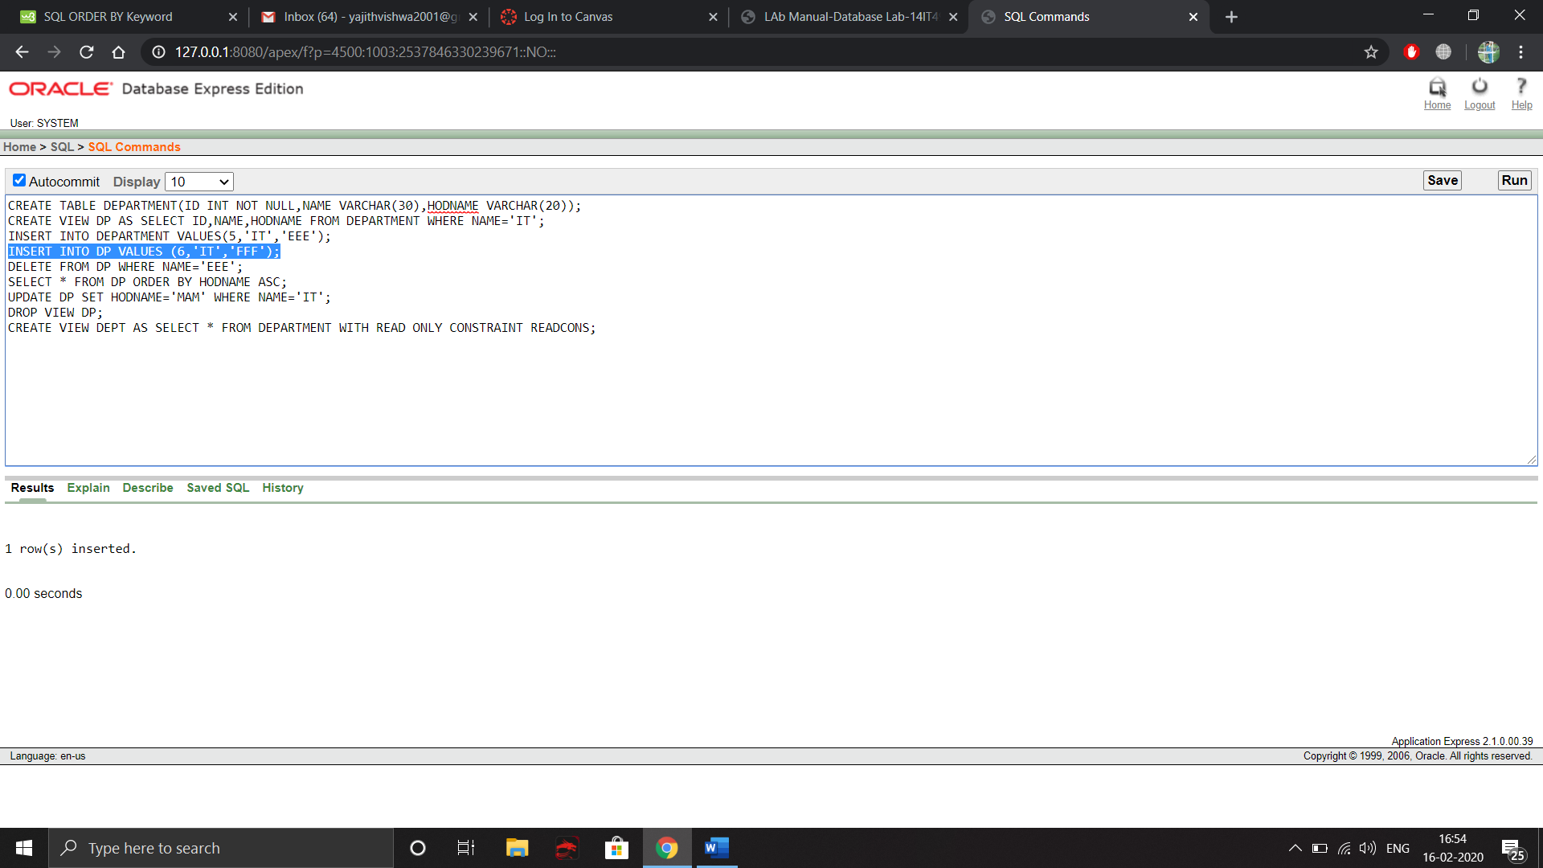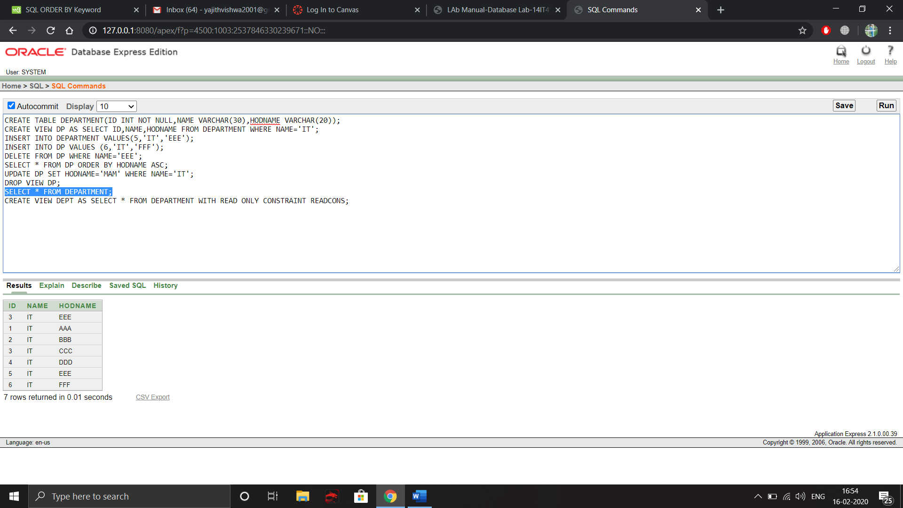

**9. Execute DML commands in main table and check whether it is reflected in view table.**

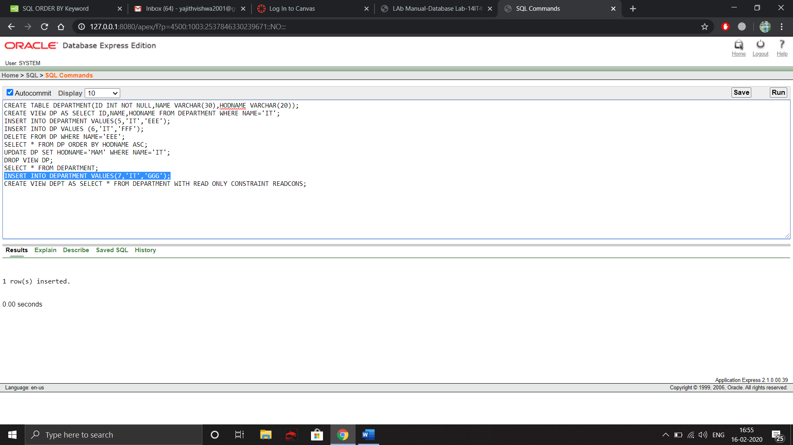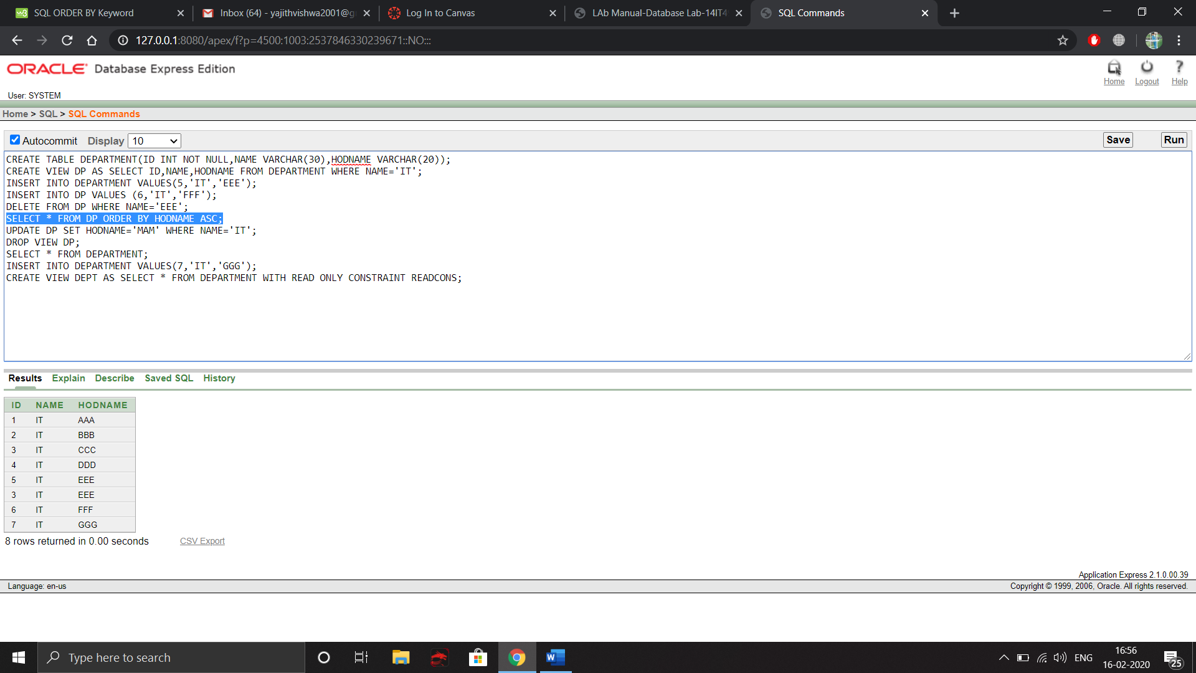

**10. Do DML operations in view table with read only constraint and tell what happens.**

